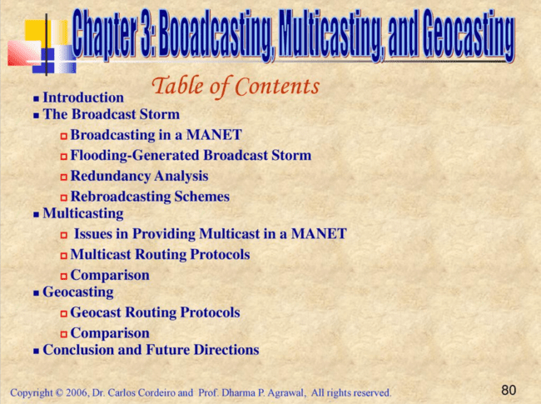

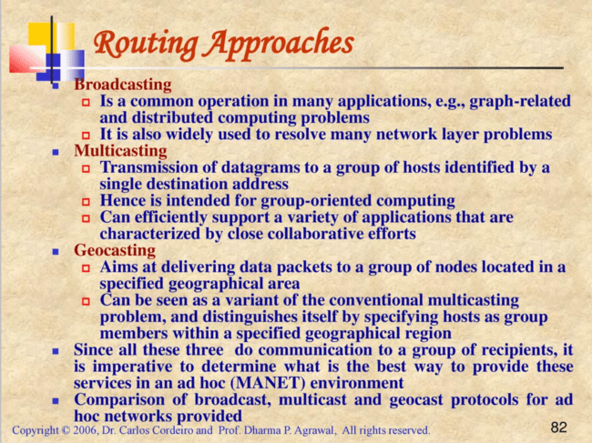

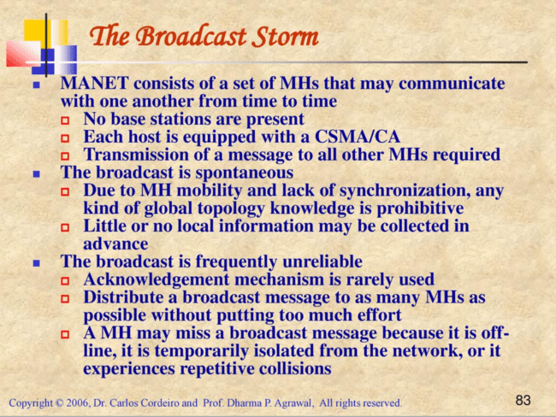

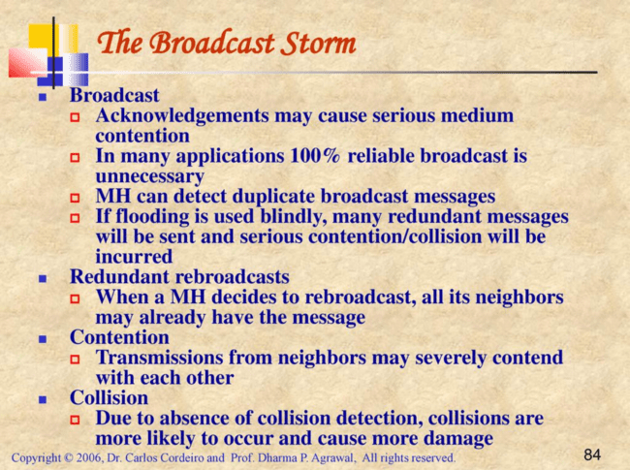

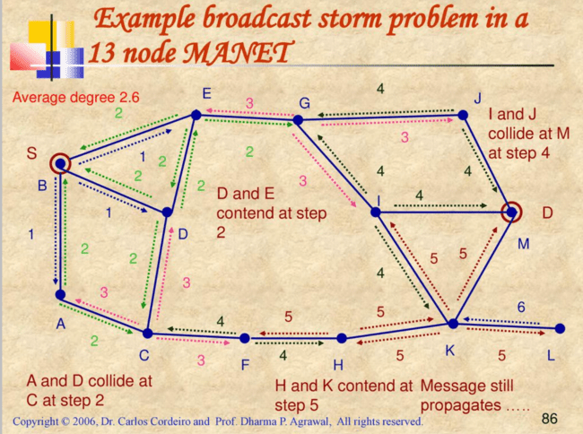

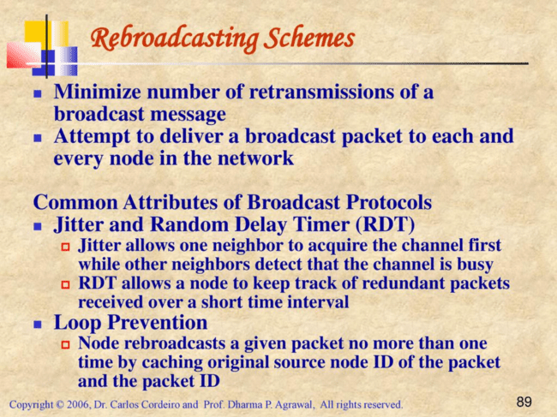

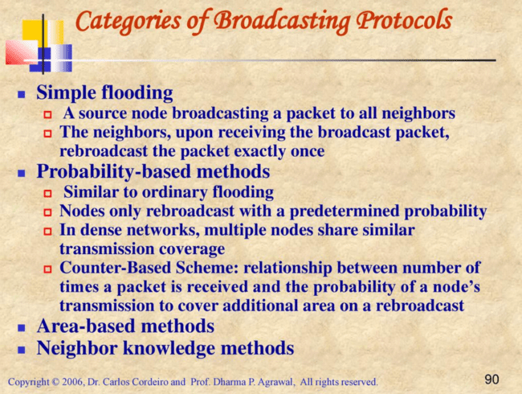

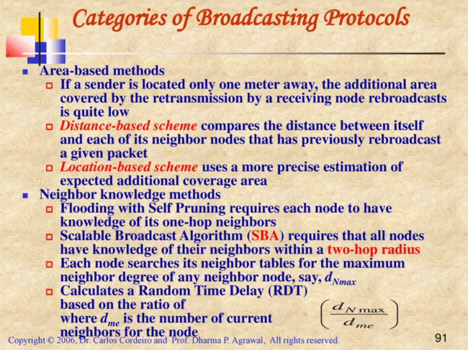

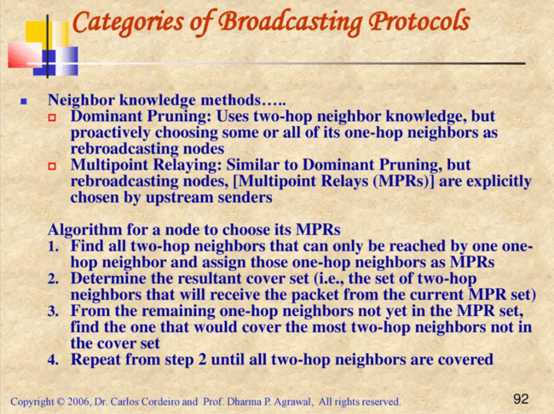

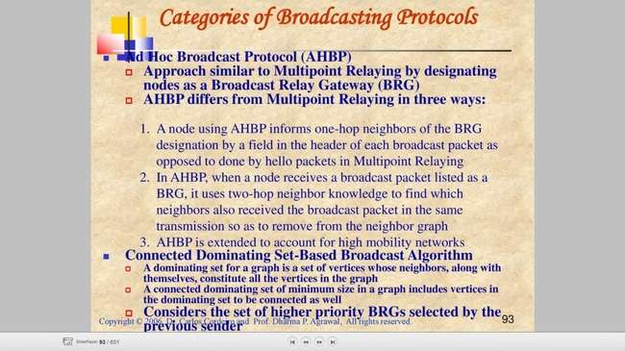

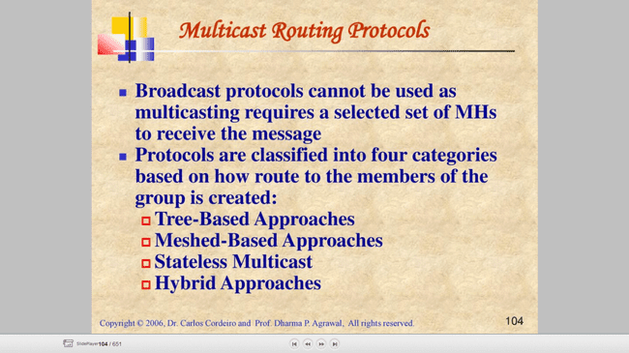

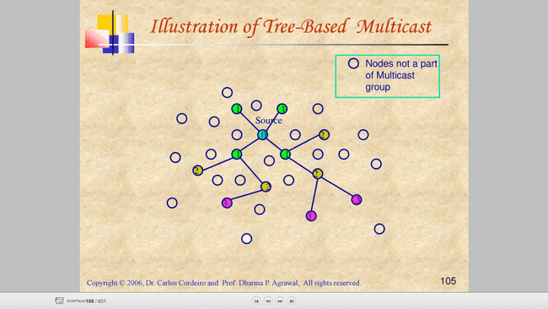

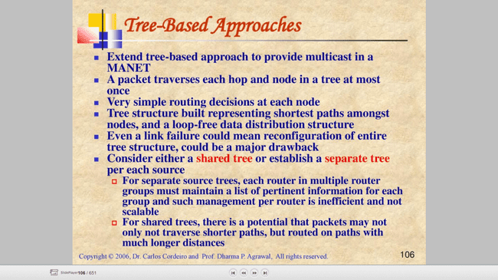

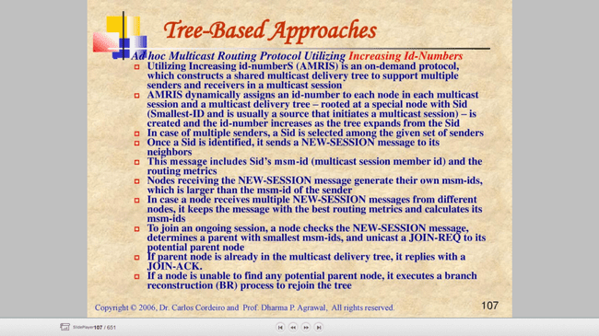

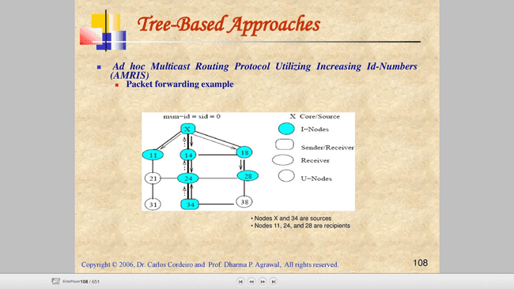

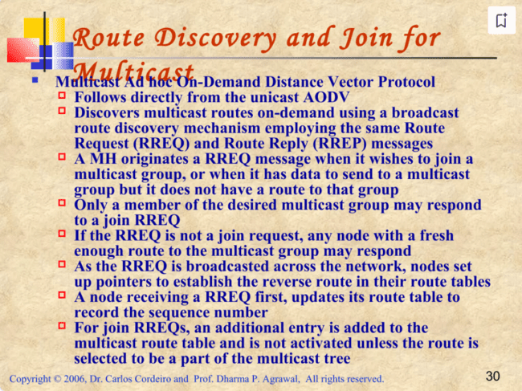

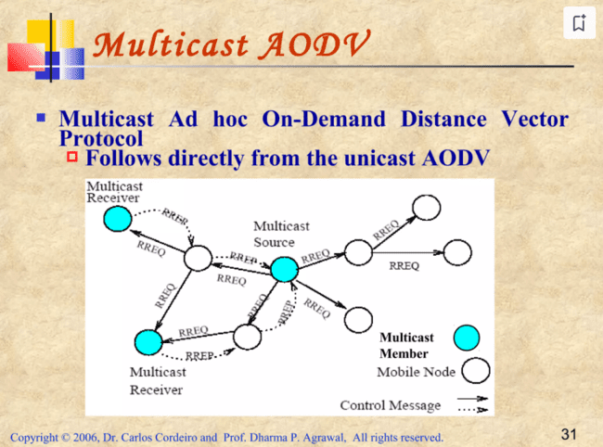

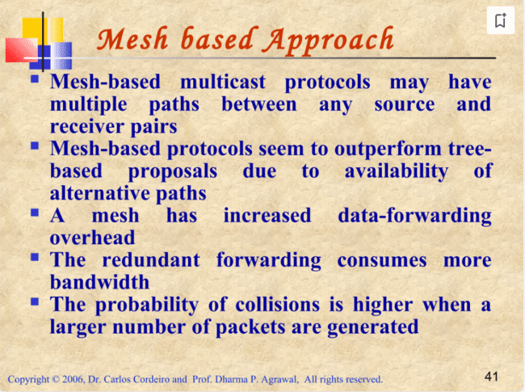

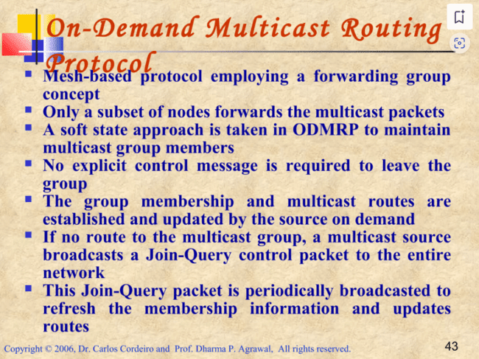

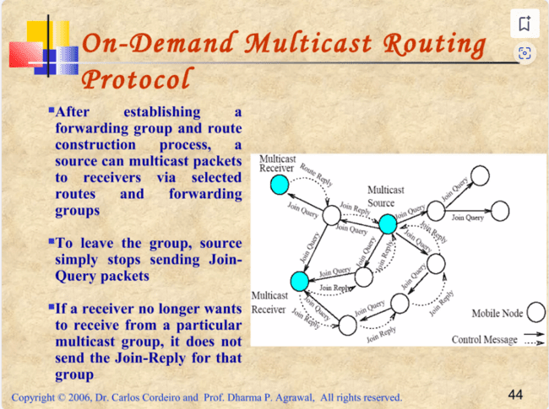

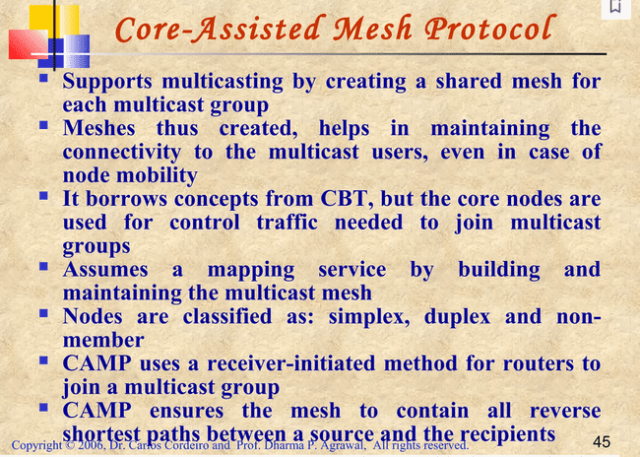

• **Multicast Mesh Creation:**

* CAMP creates a shared mesh for each multicast group, which helps maintain connectivity among multicast users, even when nodes move.
* The mesh is essentially a network of interconnected nodes that support multicast communication.

• **Control Traffic and Core Nodes:**

* CAMP uses core nodes to handle control traffic related to joining and maintaining multicast groups.
* Core nodes are crucial for managing group membership and facilitating communication within the multicast group.

• **Router Classification:**

* **Simplex Mode:** A router in this mode only sends multicast traffic received from specific nodes to the rest of the group. It does not forward multicast packets from other nodes.
* **Duplex Mode:** A router in this mode forwards multicast packets for the group and participates actively in the multicast mesh.
* **Non-Member:** A router that does not participate in the multicast mesh and does not need to forward multicast traffic.

• **Joining and Leaving Groups:**

* **Receiver-Initiated Method:** Routers join a multicast group by announcing their membership. If a router has multiple neighbors that are already members, it updates its routing table and announces itself to these neighbors.
* If no direct neighbors are members, the router sends a join request to a core node or uses an expanding ring search to find a member.
* Routers can leave a multicast group if they no longer have hosts that need the group or if they are not required for efficient packet dissemination.

• **Maintaining Connectivity:**

* CAMP ensures that all reverse shortest paths between a source and recipients are maintained in the mesh.
* Receiver nodes periodically check if they are receiving data packets via the shortest path. If not, they send a HEARTBEAT message to their successor, which triggers a PUSH JOIN (PJ) message. This process forces non-member nodes in the path to join the mesh.

• **Advantages and Disadvantages:**

* **Advantages:**
  + CAMP avoids flooding, which limits the spread of multicast join requests to mesh members only.
* **Disadvantages:**
  + It depends on an underlying unicast routing protocol to ensure that distances to all destinations are accurate and updated within a finite time frame.

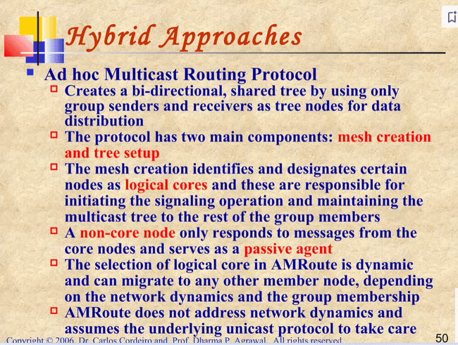

**AMRoute Protocol Overview**

1. **Core Nodes and Their Role:**
   * **Non-Core Nodes:**
     + Serve as passive agents that only respond to messages from other core nodes.
     + The selection of a logical core is dynamic and can change based on network dynamics and group membership.
2. **Mesh Creation:**
   * **Initial Process:**
     + Each member node starts by identifying itself as a core and broadcasts JOIN_REQ packets.
     + These packets use increasing Time-to-Live (TTL) values to discover other core nodes in the network.
   * **Core Response:**
     + When a core node receives a JOIN_REQ from another core node in a different mesh for the same group, it replies with a JOIN_ACK.
     + This creates a bi-directional tunnel between the two cores and one of them is selected as the core after the mesh merger.
3. **Tree Creation:**
   * **Initiation:**
     + Once the mesh is established, the core node initiates the tree creation process.
     + The core node sends periodic TREE_CREATE messages along all links in its mesh.
   * **Message Forwarding:**
     + TREE_CREATE messages are sent using unicast tunnels only to group members.
     + Group members receiving a non-duplicate TREE_CREATE message will forward it to all mesh links except the incoming one.
     + They mark the incoming and outgoing links as tree links.
   * **Handling Unused Links:**
     + If a link is not going to be used as part of the tree, the TREE_CREATE message is discarded, and a TREE_CREATE_NAK message is sent back to the incoming link.
4. **Leaving a Group:**
   * **Process:**
     + A member node wishing to leave the group sends a JOIN_NAK message to its neighboring nodes.
5. **Virtual Mesh Links:**
   * **Function:**
     + Virtual mesh links are used to establish and maintain the multicast tree.
     + This helps keep the multicast delivery tree consistent even with changes in network topology, as long as routes between core nodes and tree members exist via mesh links.
6. **Disadvantages:**
   * **Temporary Loops and Non-Optimal Trees:**
     + AMRoute may experience temporary loops and create non-optimal multicast trees due to network mobility.

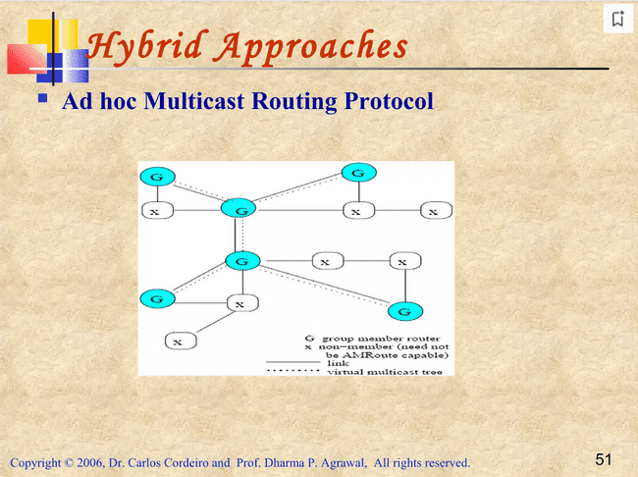

**The Multicast Core-Extraction Distributed Ad Hoc Routing (MCEDAR)** protocol is designed to enhance multicast routing by combining the strengths of tree-based and mesh-based forwarding protocols. Here’s a detailed breakdown of its components and operations:

**MCEDAR Protocol Overview**

1. **Objective:**
   * MCEDAR aims to integrate the efficiency of tree-based forwarding with the robustness of mesh-based protocols.
2. **Combining Approaches:**
   * **Tree-Based Forwarding:**
     + Creates a source-based forwarding tree on a mesh to ensure efficient data delivery.
   * **Mesh-Based Protocols:**
     + Provides robustness by using a mesh structure that can tolerate link failures.
3. **Forwarding Tree on a Mesh:**
   * **Source-Based Forwarding Tree:**
     + Built on top of the mesh infrastructure.
     + Ensures that data forwarding occurs over the shortest paths (minimum height trees).
4. **Decoupling Control and Data Forwarding:**
   * **Control Infrastructure:**
     + Separate from actual data forwarding to reduce control overhead.
   * **Unicast Protocol:**
     + The underlying unicast protocol, CEDAR, handles core broadcasting for multicasting.
5. **Core Nodes and Mesh Infrastructure:**
   * **Core Nodes:**
     + Used for routing management and link state inspection.
   * **Mesh Infrastructure (mgraph):**
     + Cores form the mesh structure (referred to as mgraph) and use join IDs to perform join operations.
6. **Mesh Tolerance:**
   * **Link Breakage Tolerance:**
     + MCEDAR can tolerate some link failures without needing reconfiguration, thanks to its mesh-based approach.
7. **Forwarding Mechanism:**
   * **Implicit Route-Based Forwarding Tree:**
     + The mesh uses this mechanism to ensure packets travel the shortest distance.
   * **Efficiency:**
     + Achieved by creating a forwarding tree on the mesh.